MBA first year students bagged almost all the prizes in 39th Inter Collegiate Quiz Debate and Essay Writing Competitions organised by KBN College on 30-11-2018
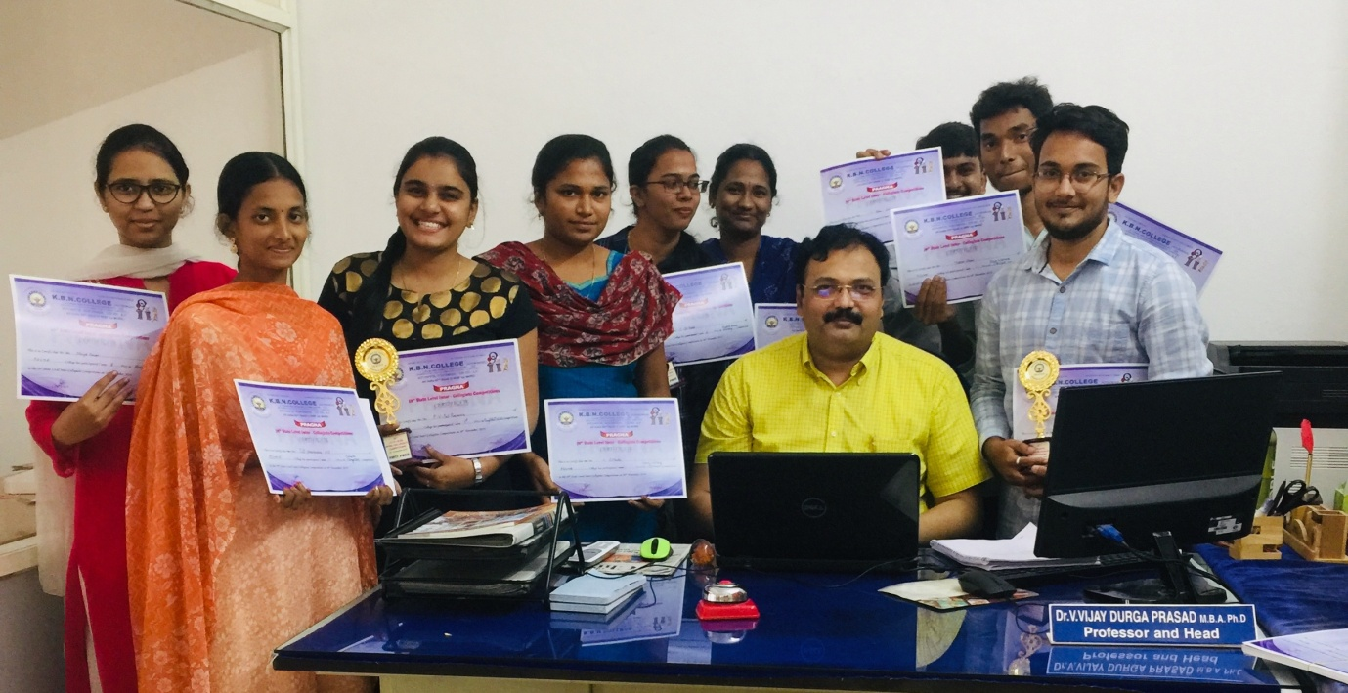

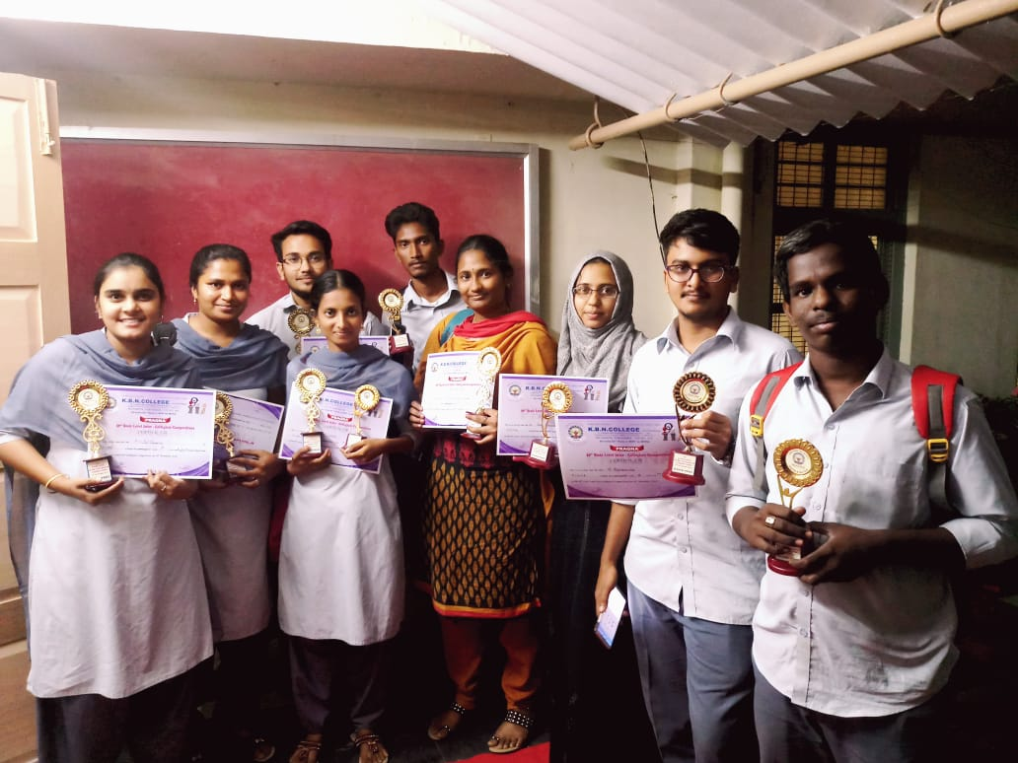

COORDINATORS HOD
1. 2.

